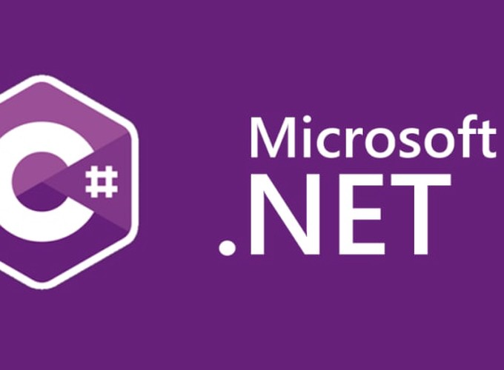

.NET Core Fundamentals

Base of .NET Core

Yash Lathiya

|  |  |  |  |
| --- | --- | --- | --- |
| Sr No. | Topic | Date | Page No. |
|  |  |  |  |
| 1 | .Net Core Overiview |  |  |
| 2 | ASP.Net Core |  |  |
| 3 | Project Structure |  |  |
| 4 | wwwroot Folder |  |  |
| 5 | Program.cs |  |  |
| 6 | Startup.cs |  |  |
| 7 | launchSettings.json |  |  |
| 8 | appSettings.json |  |  |

Table of Contents

.NET Core Overview

* .NET core is upgraded streamline of .NET framework.
* .NET framework support only windows OS while .NET core is cross-platform technology, It supports mac, windows & linux.

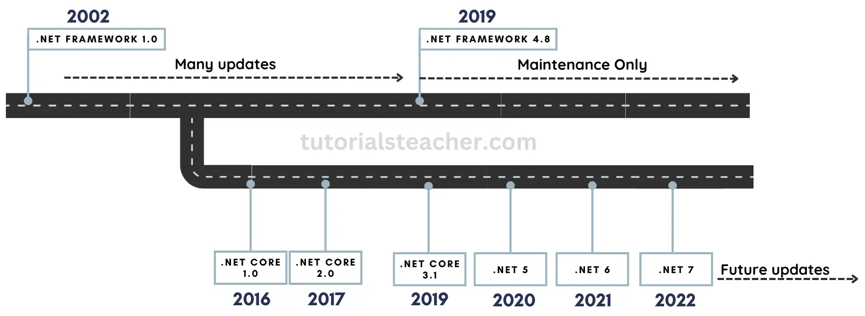

* Open Source
* Wide range of application
* Supports C#, F# & VB
* Includes CLI tools
* Supports flexible deployments (docker, user-wide & system-wide)
* High Performance
* Consistent over all architecture
* Modular Architecture

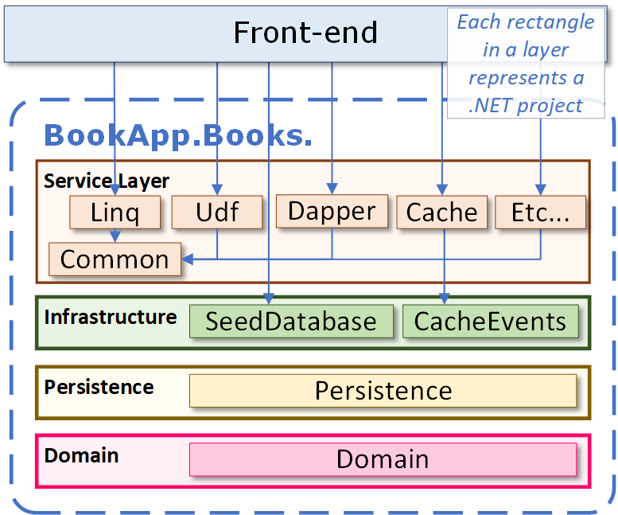

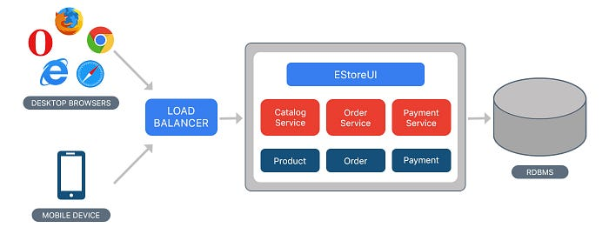[ Monolithic Architecture]  
[ mostly used for light-weight application]

[ Microservice Architecture ]  
[ mostly used for complexed application ]

[ Also needs inter service mechanism ]

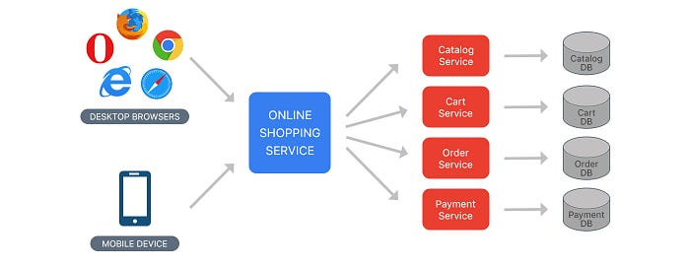

[ Modular Monolithic Architecture ]

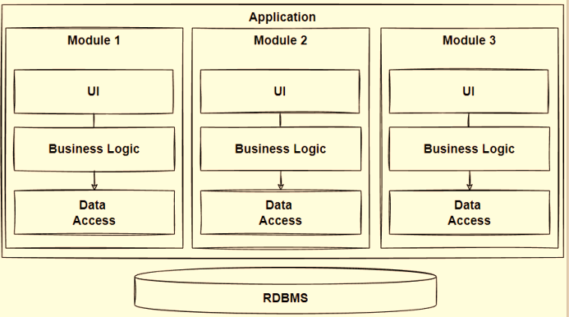

ASP .NET Core Overview

* ASP .NET is newly re-written from .NET framework,
* ASP .NET is for web application development.

Features

* Supports Multiple Platforms – OS
* Fast
* IoC Container (built-in container for automatic DI)
* Integration with modern UI Frameworks ( AngularJS, ReactJS)
* Code Sharing across versions
* Side-by-side app versioning
* Smaller deployment footprint ( size )
* Hosting

